Experiment worksheet

4.1 Synthesis and decomposition reactions can be represented by equations
Pages 90–91 and 200

Experiment 4.1A: Direct synthesis with a ‘pop’

Aim
To produce water by direct synthesis.

Materials
• Magnesium ribbon
• Dilute hydrochloric acid (1 M)
• 2 test tubes and test-tube rack
• Rubber stopper
• Wooden splint
• Matches

CAUTION: Wear protective clothing and safety glasses throughout this experiment. Avoid contact with hydrochloric acid.

Method
1 For this reaction, you require a test tube containing hydrogen gas. The easiest way to produce this is to place three 1 cm lengths of magnesium ribbon in a test tube and add 10 mL dilute hydrochloric acid (Figure 1).
2 Place the other test tube (make sure it is dry) upside down over the top of the first test tube so that any hydrogen gas produced enters the second test tube (Figure 2).

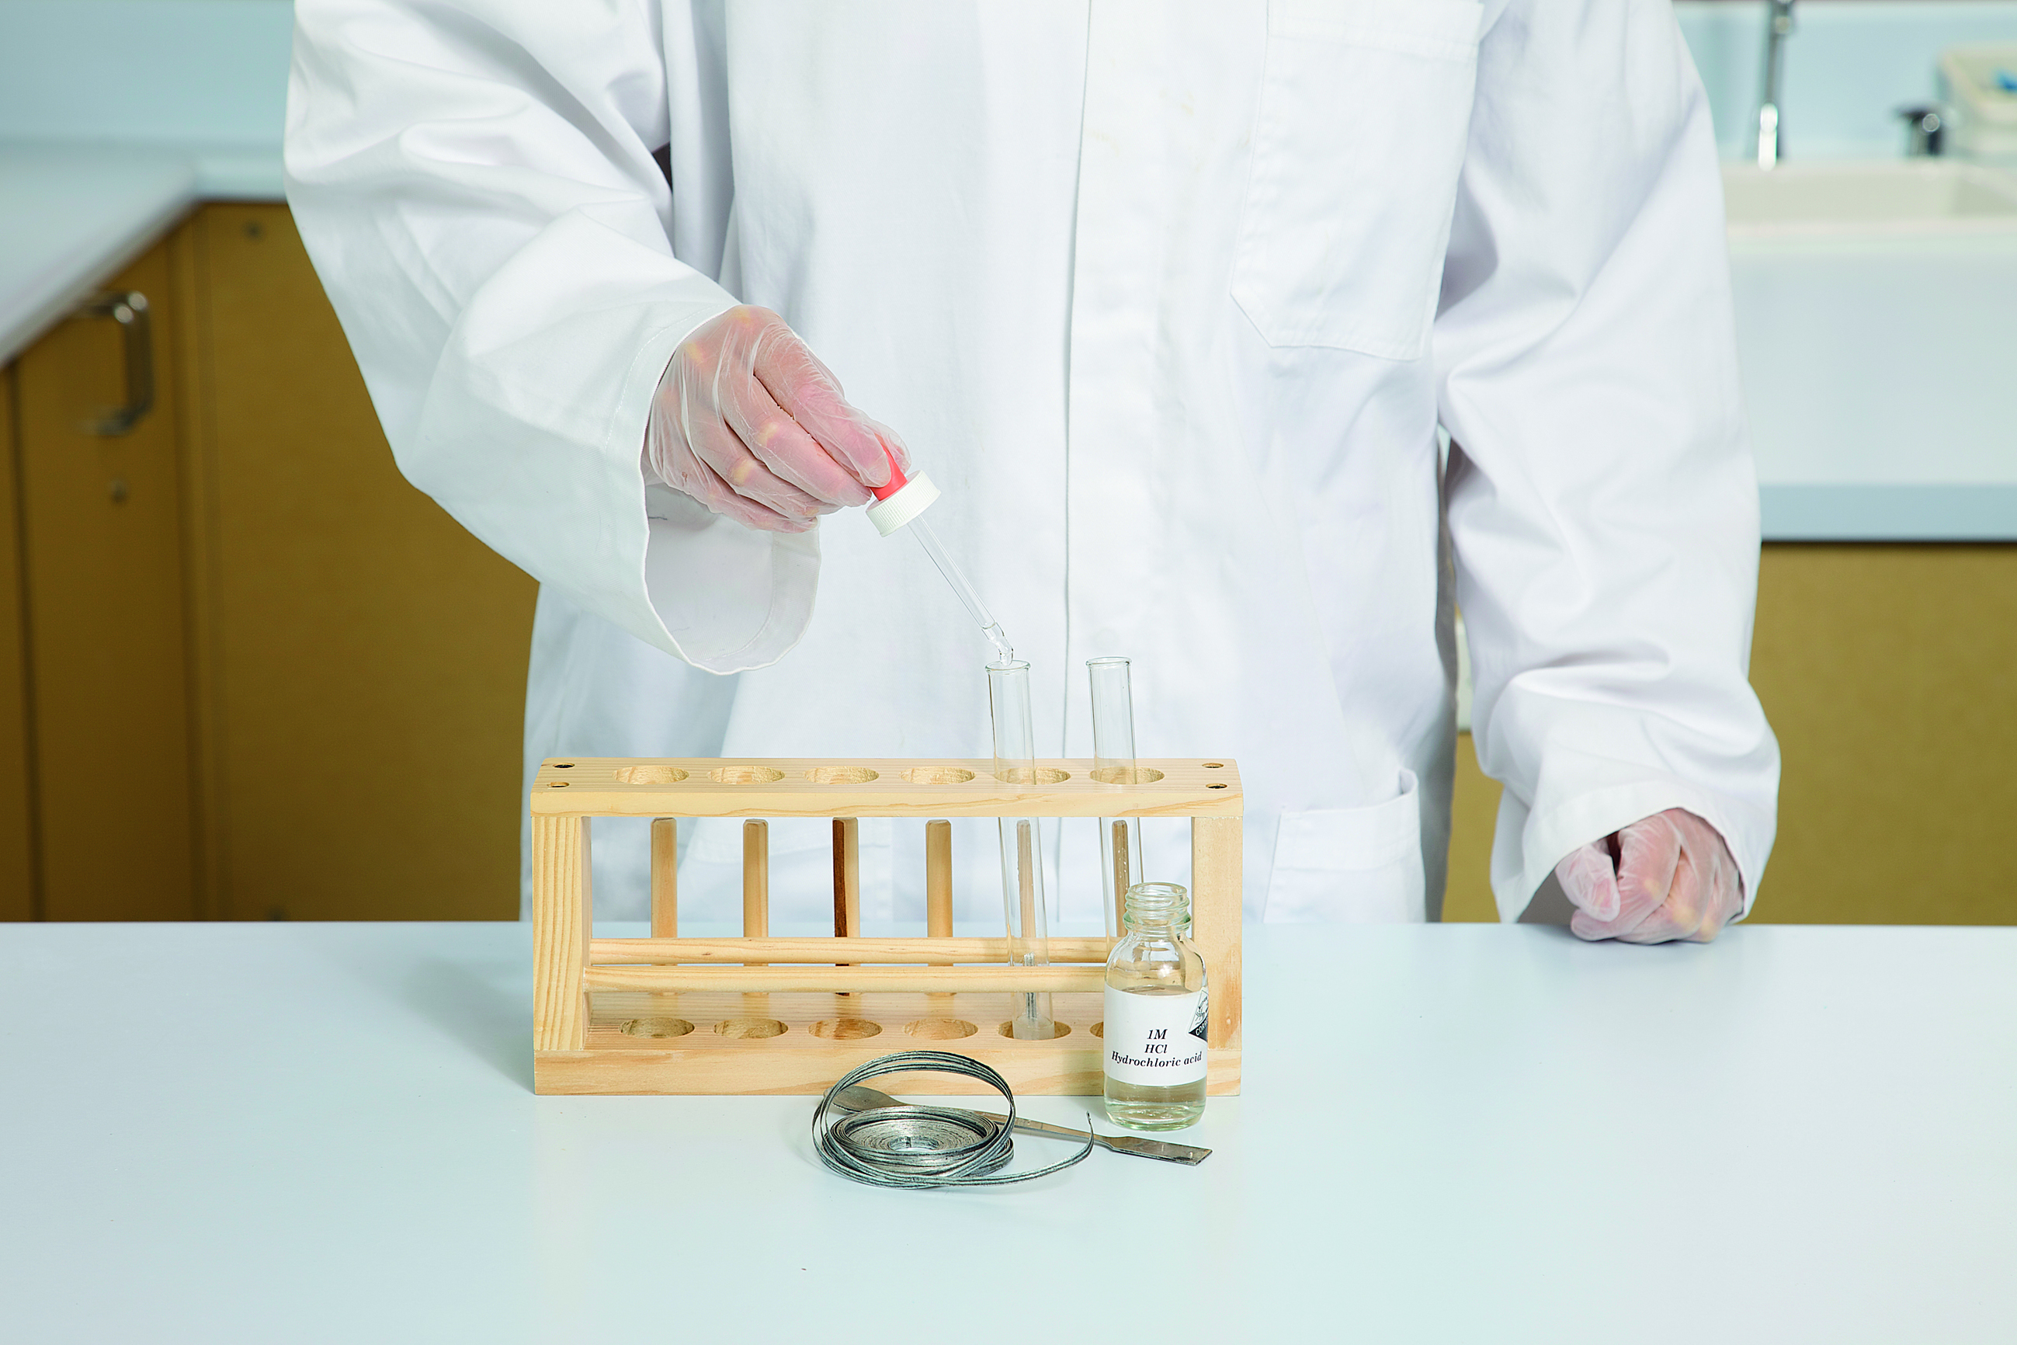
Figure 1
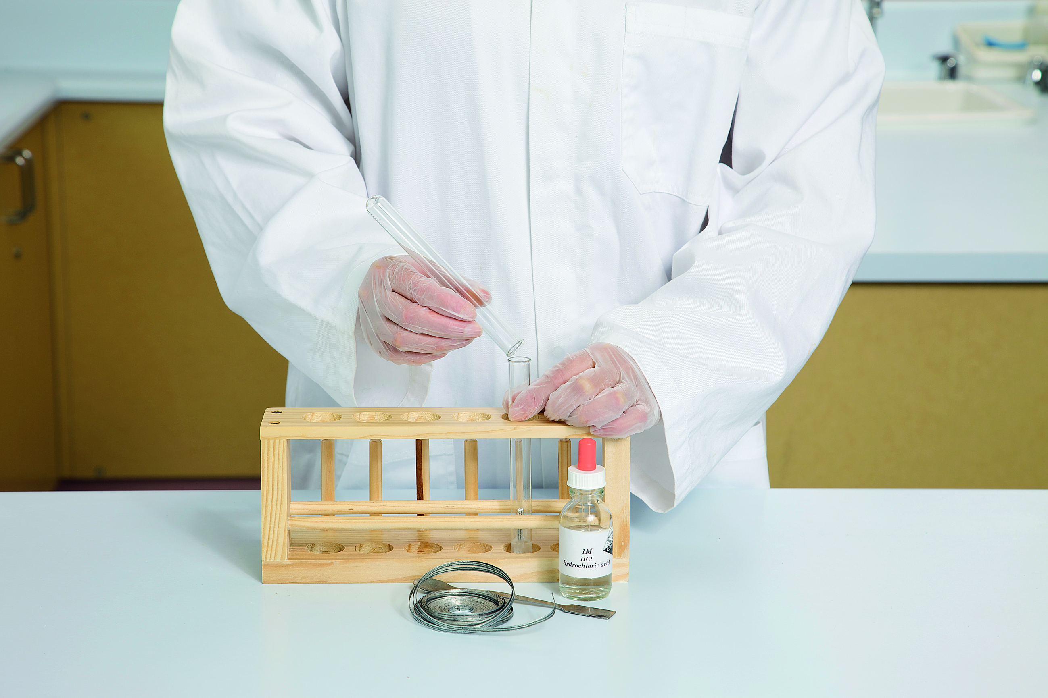
Figure 2

3 After 15 seconds, place a rubber stopper over the end of the second test tube to trap the hydrogen gas – you now have a test tube of hydrogen gas.
4 Place the sealed test tube containing the hydrogen gas into the test-tube rack.
5 Light the wooden splint. Remove the rubber stopper and carefully hold the burning splint close to the top of the test tube.
6 Observe the reaction that occurs and examine the inside of the test tube closely.

Results
Record your observations in an appropriate format.

Discussion
1 What evidence was there that water was formed in the reaction?
2 Write a chemical equation for the reaction that occurred, ensuring that no atoms are created or destroyed in the process.
3 Why do you think that heat was required to start the reaction?
4 Apart from synthesis, in what other ways could this reaction be classified? (Hint: Think about the energy involved in this reaction.)

Conclusion
What do you know about the direct synthesis of water?
Experiment worksheet

4.1 Synthesis and decomposition reactions can be represented by equations
Pages 90–91 and 201

Experiment 4.1B: Decomposing a carbonate

Aim
To use heat to decompose copper(II) carbonate to produce copper oxide and carbon dioxide.

Materials
• Copper(II) carbonate
• Copper(II) oxide
• Calcium carbonate powder
• Pyrex (high-strength) test tube
• Test-tube holder
• Bunsen burner
• Matches
• Spatula
CAUTION: Wear safety glasses throughout this experiment. Make sure that the open end of the test tube is facing in a safe direction while heating.

Method
1 Describe the appearance of copper(II) carbonate and copper(II) oxide.
2 Place one spatula of copper(II) carbonate into the test tube.
3 Hold the test tube at an angle of approximately 45° and gently heat the bottom of the test tube by moving it carefully in and out of a Bunsen burner flame (Figure 1).
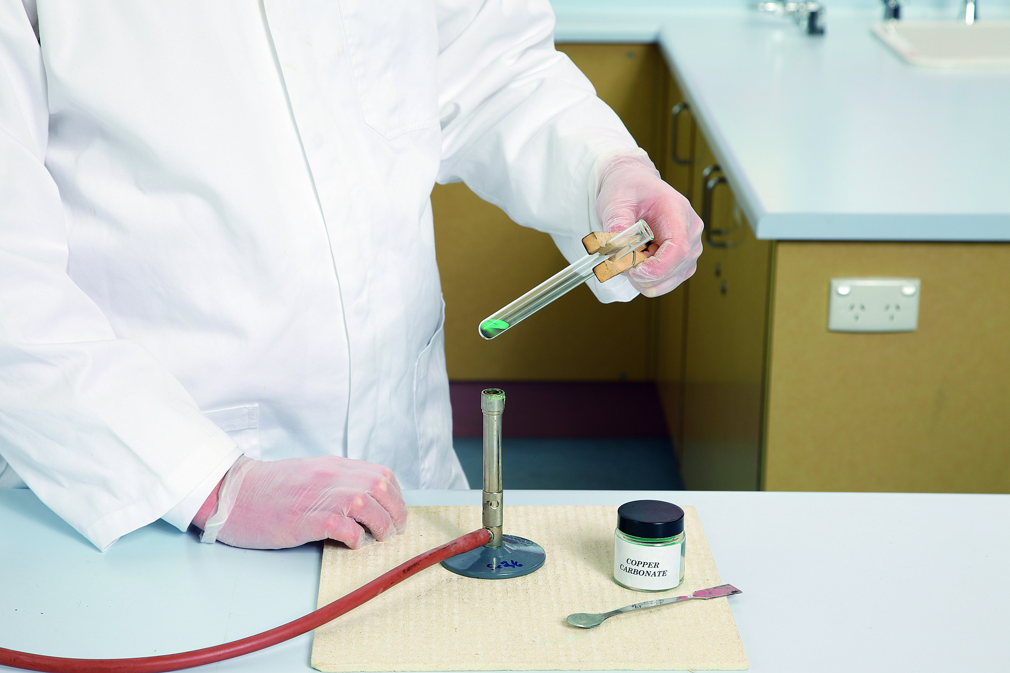 Figure 1
4 Carefully observe the changes that occur.

Results
Record your observations in an appropriate format.

Discussion
1 What evidence is there that copper(II) oxide was formed in the reaction?
2 What evidence is there that a gas was given off in the reaction?
3 Write a chemical equation for the reaction that occurred, including state symbols.
4 Apart from decomposition, what other ways could this reaction be classified?

Conclusion
What do you know about the decomposition equations?

Further investigation
How could you redesign this experiment to provide evidence that it is carbon dioxide gas that is produced in the reaction? Write an experimental method, including labelled diagrams, and list any additional equipment you will need. Show your design to your teacher and, if it is safe, try your method using copper(II) carbonate and then repeat using calcium carbonate.
Experiment worksheet

4.1 Synthesis and decomposition reactions can be represented by equations
Pages 90–91 and 202

Experiment 4.1C: Electrolysis

Aim
To use electricity to produce copper metal from copper(II) sulfate.

Materials
• Copper(II) sulfate
• 100 mL beaker
• Stirring rod
• Spatula
• DC power supply
• 3 leads
• 12 V globe and globe holder
• Wires with alligator clips
• 2 carbon rods
CAUTION: Wear safety glasses throughout this experiment. Do not let the carbon rods touch when they are in the beaker. Ensure that liquid does not contact the power source at any time

Background
Copper sulfate (CuSO4) is an ionic substance containing copper(II) ions (Cu2+) and sulfate (SO42–) ions.

Method
1 Add one spatula of the copper(II) sulfate to the beaker and half fill it with water.
2 Stir until the crystals are all dissolved.
3 Set the power supply to a maximum of 6 V and connect the circuit as shown in Figure 1.
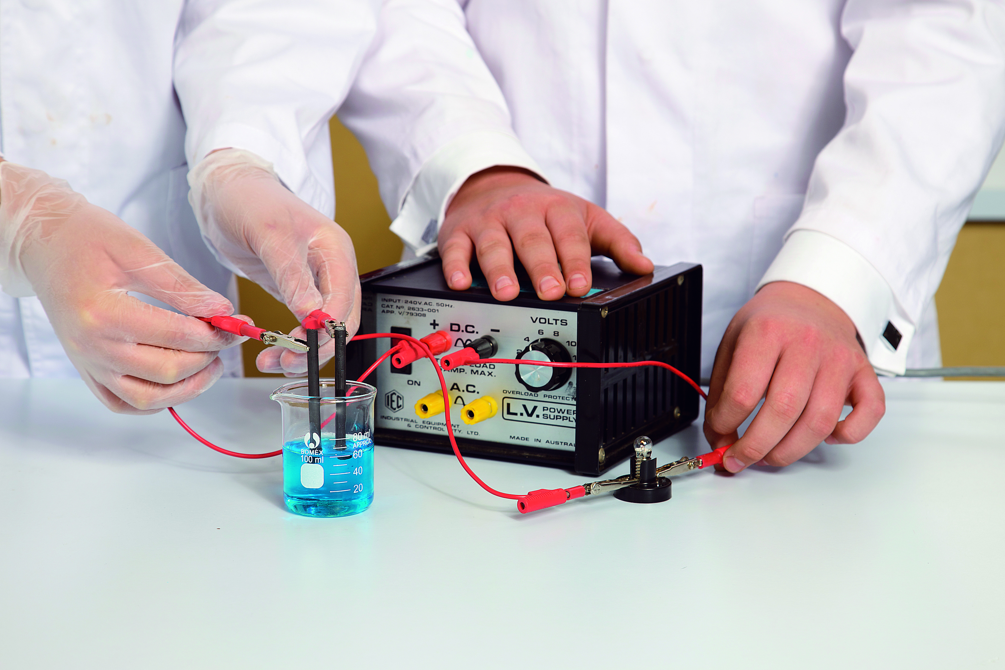
Figure 1
4 Touch the carbon rods together to check the circuit works and then place the carbon rods in the beaker with a 1 cm gap between them.
5 Hold the rods in place for 30 seconds and observe any changes that occur.
6 Turn off the power supply.

Results
Record your observations in an appropriate format.

Discussion
1 What evidence was there that copper was formed in the reaction?
2 Considering the structure of the copper sulfate, describe the:
• role of the water in the process
• role of the electric circuit
• reason that the copper was only found on one of the carbon electrodes.
3 Do you think that a usable amount of copper could be produced this way? If not, what changes would need to be made to the set-up to produce more copper?

Conclusion
Was this a synthesis or decomposition reaction? Provide evidence from your results to support your answer.
Experiment worksheet

4.2 Acid reactions depend on strength and concentration
Pages 92–93 and 203

Experiment 4.2: Acid titrations

Aim
To compare the reactions of a strong acid, hydrochloric acid, and a weak acid, ethanoic acid, (common name acetic acid).

Materials
• Dropper bottles containing:
– 0.1 M hydrochloric acid (HCl)
– 0.1 M ethanoic acid (acetic acid) (CH3COOH)
– 0.1 M sodium hydroxide (NaOH)
– 1 M hydrochloric acid (HCl
– 1 M ethanoic acid (acetic acid) (CH3COOH)
– universal indicator solution
• pH colour chart
• Small pieces of magnesium ribbon
• 4 test tubes and test-tube rack
• Dropping pipette
• Matches
CAUTION: Wear a laboratory coat, gloves and safety glasses throughout this experiment. Most of the substances used in this experiment need to be handled with care.

Method
PART A
1 Draw up a table to record each test and the results for each acid.
2 Place 2 mL of 0.1 M hydrochloric acid in one test tube and add 2 drops of universal indicator solution. Record the colour of the indicator and the corresponding pH from the colour chart.
3 Repeat step 2 with 0.1 M ethanoic acid, using a fresh test tube.
4 To the first test tube add 0.1 M sodium hydroxide drop by drop, counting the drops, until the solution is neutral (i.e. pH = 7).
5 Repeat step 4 with ethanoic acid.
PART B
1 Add 2 mL of 1 M hydrochloric acid to a fresh test tube.
2 Add a small piece of magnesium ribbon to the test tube and invert a clean test tube over the top so there is only a small gap between the test tubes.
3 Record your observations.
4 Lightly touch the base of the bottom test tube. Record your observations of the temperature of the mixture.
5 When the reaction has ceased, light a match and hold it just inside the inverted test tube. Do you hear a loud popping sound? This is evidence of hydrogen gas being produced.
6 Repeat steps 1–6 with 2 mL of 1 M ethanoic acid.

Results
Record your results in an appropriate table.

Discussion
1 When you tested the pH of the two acids, you used the same concentration (0.1 M).
a Why were they compared at the same concentration?
b Why did they have a different pH?
c What can be concluded about the strength of ethanoic acid compared with the strength of hydrochloric acid?
2 Compare the number of drops of sodium hydroxide used to neutralise each acid. Is this what you expected? Explain using your results.
3 Write a balanced equation for each neutralisation reaction.
4 The pop test is the standard test for hydrogen gas. The ‘pop’ sound is a mini-explosion due to the combustion of hydrogen gas in air, which is a very exothermic (heat producing) reaction.
The equation for the reaction is: 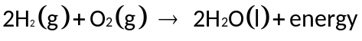
a Did your tests confirm that hydrogen gas was produced?
b Was there a difference in how fast the reactions with the two different acids occurred? If so, suggest why.
5 Write a balance chemical equation for the reaction between the two acids and the magnesium ribbon.

Conclusion
1 What do you know about neutralisation reactions?
2 What do you know about reactions between metals and acids?
3 What do you know about the difference between strength and concentration of acids?

Experiment worksheet

4.3 The solubility rules predict the formation of precipitates
Pages 94–95 and 204

Experiment 4.3: Precipitation reactions

Aim
To determine which compounds form precipitates and write equations for the reactions occurring.

Materials
• Plastic document sleeve
• Dropper bottles containing 0.1 M solutions of:
Group A:
calcium nitrate (Ca(NO3)2), copper(II) nitrate (Cu(NO3)2), magnesium nitrate (Mg(NO3)2),
silver nitrate (AgNO3), copper(II) sulfate (CuSO4)
Group B:
sodium chloride (NaCl), sodium hydroxide (NaOH), sodium sulfate (Na2SO4), sodium carbonate (Na2CO3)

Method
1 Draw up a large table as shown here with group B solutions listed across the first row and group A solutions in the first column as shown here:
 | NaCl | NaOH | Na2SO4 | Na2CO3
Ca(NO3)2
Cu(NO3)2
Mg(NO3)2
AgNO3
CuSO4
2 Make a second copy of your results table on a piece of A4 paper and place this table into the plastic document sleeve. Place this on the laboratory bench. This now becomes your working area for the experiment and you will add drops of the solutions to corresponding cells on the results table, which is now protected by the plastic sleeve.
3 Place 1 drop of each of the group A solutions in each cell of the results table in the correct row.
4 Add 1 drop of each of the group B solutions to the drops of the group A solutions in the correct columns.

Results
1 Record whether a precipitate forms, as well as its appearance, on your other copy of the results table.
2 Use Table 4.1 (page 94) to help you answer the following questions. For each precipitate formed:
a identify the ions that have combined to form the precipitate and write the formula of the ions
b write the formula of the precipitate
c write a word equation for the reaction.

Discussion
1 The sets of compounds tested included a range of anions: NO3–, OH–, CO32–, Cl– and SO42–. Of these, which:
a did not form any precipitates?
b only formed precipitates with one or two cations?
2 The sets of compounds tested included a range of cations: Na+, Ag+, Cu2+, Ca2+ and Mg2+. Of these, which:
a did not form any precipitates?
b formed precipitates with only one or two anions?
3 Did the precipitation reactions you observed match those predicted from Table 4.1? Discuss why or why not.

4 Write balanced chemical equations for the reactions between:
a silver nitrate and sodium chloride
b magnesium nitrate and sodium hydroxide.
5 Why is it important not to touch the tip of the dropper bottles on the top of the solution already on the plastic sleeve?
6 What other factors may affect the outcome of these precipitation reactions?

Conclusion
What do you know about predicting precipitation reactions?

Experiment worksheet

4.4 Combustion reactions between hydrocarbons and oxygen produce carbon dioxide, water and energy
Pages 96–97 and 205

Experiment 4.4: Combustion of wire wool

Aim
To observe the oxidation of wire wool.

Materials
• Wire wool
• 9 V battery
• Crucible
• Bench mat
• Scales
CAUTION: Wear a laboratory coat and safety glasses throughout this experiment. The wire wool becomes very hot. Use a nonflammable bench mat. Do not touch the wool until it has cooled.

Method
1 Make a small ball out of the wire wool and place it in the crucible.
2 Record the weight of the crucible and wire wool.
3 Place the crucible in the centre of the bench mat.
4 Quickly touch both terminals of the 9 V battery to the wool and then pull them away (Figure 1) (If the wool sticks to the battery, use a small spatula to separate them.)
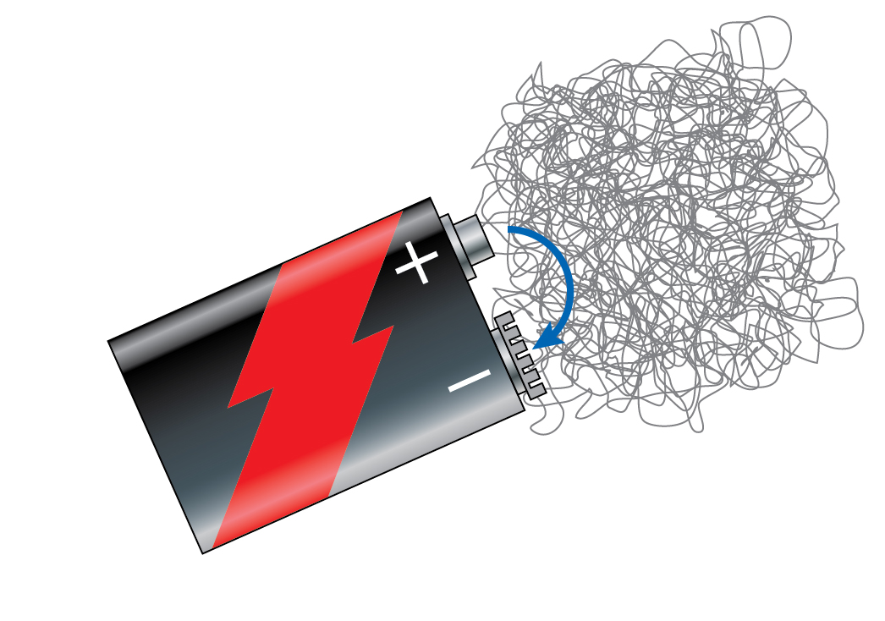
Figure 1
5 Write your observations of the reaction.
6 When the wire wool has stopped reacting, weigh the crucible and contents a second time.

Results
Record your masses and observations in an appropriate table.

Discussion
1 Was this reaction an exothermic or endothermic reaction?
2 Was there any change in the mass of reactants and products? Explain your observation.
3 Write a worded equation for this reaction.
4 Write a balanced chemical reaction for this reaction.

Conclusion
What do you know about the oxidation of wire wool?
Experiment worksheet

4.5 Polymers are long chains of monomers
Pages 98–99 and 206

Experiment 4.5: Polymerisation of casein

Aim
To form polymers of casein monomers.

Materials
• 100 mL full cream milk
• 5 mL ethanoic acid (acetic acid) (CH3COOH)
• Bunsen burner
• Tripod
• Thermometer
• Gauze mat
• Bench mat
• Spatula
• Filter paper
• Funnel
• Beaker
• Conical flask
Milk contains a protein called casein. When milk is heated and mixed with an acid, such as the ethanoic acid in vinegar, the casein monomers bond with each other to form long polymers. Before World War II, casein plastic was used to make buttons, beads and jewellery.

Method
1 Place 100 mL of milk in a beaker and heat it over the Bunsen burner until it is above 49°C.
2 Remove the milk from the Bunsen burner and place it on the bench mat.
3 Add 5 mL of ethanoic acid to the milk. The milk will separate into curds.
4 Place the filter paper in the funnel and filter the casein polymer curds from the whey.
5 Weigh the casein polymer you obtained.
6 Mould the casein plastic into a shape of your choice.

Inquiry
Choose one of the following questions to investigate.
• What if low-fat milk was used?
• What if more vinegar was used?
• What if less vinegar was used?
Answer the following questions in relation to your inquiry.
1 Write a hypothesis for your question.
2 What is your independent variable?
3 What is your dependent variable?
4 Name three controlled variables and explain how you will control them.

Results
Record your observations and measurements in a table.

Discussion
1 What are the reactants used?
2 What are the products produced?
3 What changes have taken place?
4 Is the polymer you created a thermoplastic or thermoset plastic? How could you test this?
5 State a use for this polymer and what properties make it suitable for that use.

Conclusion
What do you know about polymerisation?

Experiment worksheet

4.6 Temperature, concentration, surface area and stirring affect reaction rate
Pages 100–103 and 207

Experiment 4.6A: Effect of temperature on reaction rate

Aim
To investigate the effect of temperature on reaction rate.

Materials
• 0.001 M potassium permanganate solution
• 0.005 M oxalic acid solution
• Test tubes
• Stopwatch
• 250 mL beaker
• 10 mL measuring cylinders
• Safety glasses
• Kettle or access to hot water
• Thermometer
CAUTION: Wear protective gloves, a laboratory coat and safety glasses throughout this experiment. Avoid contact with the potassium permanganate solution and oxalic acid solution.

Method
1 Construct a hypothesis for your experiment.
2 This experiment can be performed using a water bath to warm or cool specific amounts of the two solutions to the required temperature before they are mixed. Once mixed, leave the test tube containing the reaction mixture in the water bath while you measure the reaction time. (The reaction is finished when the purple colour of the potassium permanganate disappears.)
3 Consider what different temperatures you will use, how the temperature will be measured, what volumes of solutions should be used and how the results will be best presented.
Hint: Potassium permanganate is toxic to the environment. Try to minimise the amounts used in this experiment.
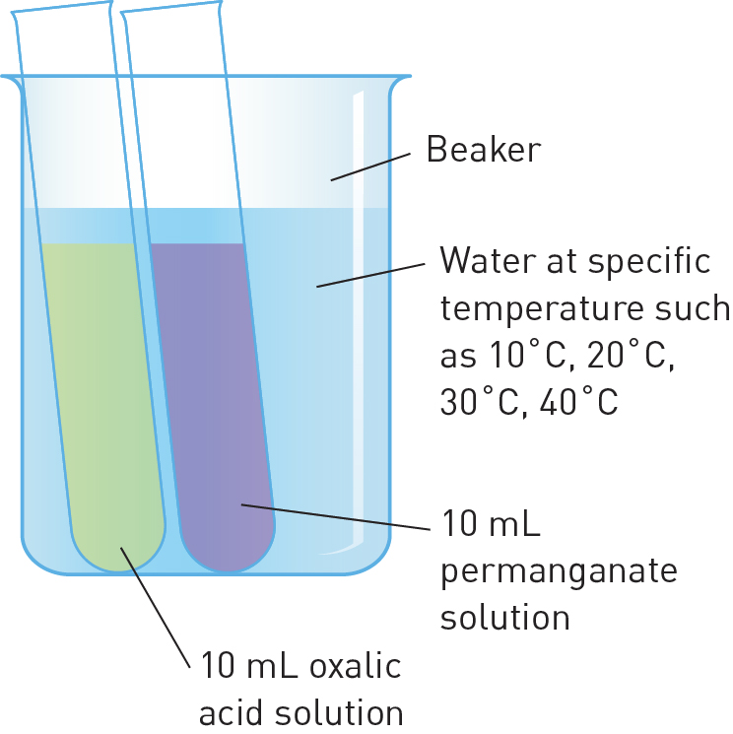
Figure 1 A water bath can be used to control the temperature of the solutions.

Conclusion
Write a conclusion for your experiment that includes a discussion of your hypothesis based on the data from the experiment and an evaluation of the methods used to produce these data.
Experiment worksheet

4.6 Temperature, concentration, surface area and stirring affect reaction rate
Pages 100–103 and 208

Experiment 4.6B: Factors affecting reaction rate

Aim
To investigate the rates of a reaction between hydrochloric acid and calcium carbonate.

Materials
• 30 g small marble chips (calcium carbonate) of similar size
• 20 mL of 0.5 M hydrochloric acid (HCl)
• 20 mL of 1.0 M HCl
• 20 mL of 2.0 M HCl
• Electronic balance
• Stopwatch
• 25 mL measuring cylinder
• 3 × 100 mL conical flasks
CAUTION: Wear protective gloves, a laboratory coat and safety glasses throughout this experiment. Avoid contact with the acid solutions because they are corrosive. If acid comes into contact with your skin, wash it with water immediately.

Method
1 Place a conical flask on the electronic balance and tare the balance so it reads zero. Weigh approximately 10 g of identical-sized marble chips into the flask.
2 Using a measuring cylinder add 20 mL of 0.5 M HCl to the conical flask still sitting on the electronic balance. Immediately tare the balance once so that it returns to zero briefly, and start the stopwatch. The numbers on the balance will move into negative readings from zero, as gas is given off.
3 Record in your results table the mass loss in grams at 30 seconds, 1 minute and then every minute until 8 minutes.

Inquiry
Choose one of the following questions to investigate.
• What if the marble chips were smaller?
• What if the acid was more concentrated?
Answer the following questions in relation to your inquiry.
1 Construct a hypothesis for your experiment.
2 What independent variable are you investigating?
3 How will you measure your dependent variable?
4 Name three variables that you will control. How will you control them?
5 Write your method step by step and check it with your teacher.
6 Is this experiment safe?
7 What personal protective equipment will you need?
8 How will you record your results? Will the results be quantitative or qualitative?

Results
Copy and complete the following table and plot a graph of the mass loss by minutes.
Dependent variable | 30 s | 1 min | 2 min | 3 min | 4 min | 5 min | 6 min | 7 min | 8 min

Discussion
1 Write a balanced chemical equation for the chemical reaction.
2 Describe the relationship between your independent variable and dependent variable as shown by your graph.
3 Is the hypothesis supported by the results?
4 Name two possible sources of error in your experiment. How could you improve the quality of the evidence that was obtained in the experiment?

Conclusion
Write a conclusion of your experiment that includes a general statement that summarises the evidence that supports your hypothesis.
Experiment worksheet

4.7 Catalysts increase the rate of a reaction
Pages 104–105 and 209

Experiment 4.7: Using a catalyst

Aim
To investigate the effect of adding a catalyst to a reaction. The reaction used in this experiment is the decomposition of hydrogen peroxide: 2H2O2(aq) → 2H2O(l) + O2(g)

Materials
• Hydrogen peroxide (H2O2) solution (10 volume)
• Manganese dioxide (MnO2) powder
• Test tubes
• Spatula

Method
1 Place 5 mL of hydrogen peroxide solution into two separate test tubes.
2 Allow one of the tubes to stand; add a small amount of manganese dioxide to the other test tube using a spatula.
3 Observe and describe the changes that occur in the two test tubes.

Results
Record your observations in an appropriate format.

Discussion
1 Was there any evidence of reaction in the test tube in which manganese dioxide was not added?
2 Would you say that the manganese dioxide acted as a catalyst in this reaction? Justify your answer.

Conclusion
3 What do you know about how catalysts affect the rate of a reaction?

